FINANCE ANALYSIS PROJECT
- BANK LOAN REPORT | SUMMARY
KPI’S
Total Loan Applications
Select count(id) as total_application from finance 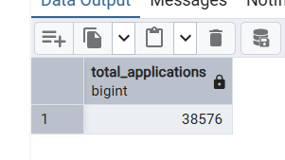
MTD Loan application
SELECT COUNT (id) as MTD_APPLICATION FROM finance
WHERE EXTRACT (MONTH from issue_date) =12-- DECEMBER
AND EXTRACT (YEAR FROM issue_date) = 2021

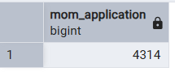

PMTD APPLICATION
SELECT COUNT(id) as PMTD_APPLICATION FROM finance
WHERE EXTRACT(MONTH from issue_date)=11
AND EXTRACT (YEAR FROM issue_date ) =2021

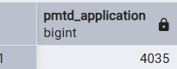

MTD AMOUNT FUNDED
SELECT SUM(loan_amount) as total_funded
from finance
WHERE EXTRACT(MONTH from issue_date)=12-- DECEMBER
AND EXTRACT (YEAR FROM issue_date) = 2021

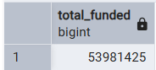

PMTD AMOUNT FUNDED

SELECT SUM(loan_amount) as total_funded
from finance
WHERE EXTRACT(MONTH from issue_date)=11-- NOVEMBER
AND EXTRACT (YEAR FROM issue_date) = 2021
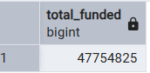

TOTAL AMOUNT RECEIVED

SELECT SUM(total_payment) AS BANK_LOAN_DATA
FROM FINANCE ;
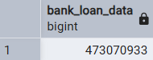

MTD AMOUNT RECEIVED
SELECT SUM(total_payment) AS mtd_BANK_LOAN_DATA
FROM FINANCE
WHERE EXTRACT (MONTH FROM issue_date) = 12
AND EXTRACT (YEAR fROM issue_date )= 2021;

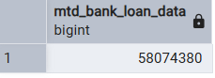
MTD AMOUNT RECEIVED
SELECT SUM(total_payment) AS PMTD_BANK_LOAN_DATA
FROM FINANCE
WHERE EXTRACT (MONTH FROM issue_date) = 11
AND EXTRACT (YEAR fROM issue_date )= 2021;

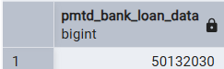

AVG INTEREST RATE
SELECT concat(round(( AVG(int_rate)*100)::numeric,2 ),' %') as AVG_INT_RATE
FROM finance;
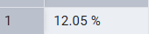
MTD_AVG INTEREST RATE
SELECT concat(round(( AVG(int_rate)*100)::numeric,2 ),' %') as MTD_AVG_IN_RATE
FROM finance
WHERE EXTRACT (MONTH FROM issue_date) = 12
AND EXTRACT (YEAR fROM issue_date )= 2021;

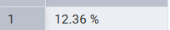

PMTD_AVG INTEREST RATE
SELECT concat(round(( AVG(int_rate)*100)::numeric,2 ),' %') as MTD_AVG_IN_RATE
FROM finance
WHERE EXTRACT (MONTH FROM issue_date) = 11
AND EXTRACT (YEAR fROM issue_date )= 2021;

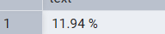

AVG DEBT TO INCOME RATE
SELECT concat(round(( AVG(dti)*100)::numeric,2 ),' %') as MTD_AVG_DTI
FROM finance
WHERE EXTRACT (MONTH FROM issue_date) = 12
AND EXTRACT (YEAR fROM issue_date )= 2021;

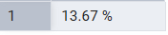

PMTD AVG DEBT TO INCOME RATE

SELECT concat(round(( AVG(dti)*100)::numeric,2 ),' %') as PMTD_AVG_DTI
FROM finance
WHERE EXTRACT (MONTH FROM issue_date) = 11
AND EXTRACT (YEAR fROM issue_date )= 2021;

GOOD LOAN AND BAD LOAN
SELECT LOAN_STATUS FROM FINANCE;
SELECT
(COUNT( CASE WHEN loan_status ='Fully Paid' or loan_status ='Currrent'
THEN id end)*100)
/ count(id) as good_loan_percentage
from finance;

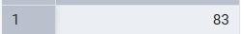

find good loan application
SELECT COUNT(ID) AS APPLICATION
FROM FINANCE
WHERE loan_status ='Fully Paid' or loan_status='Current';

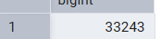

GOOD LOAN FUNDED AMOUNT
SELECT SUM(total_payment) AS APPLICATION_funded
FROM FINANCE
WHERE loan_status ='Fully Paid' or loan_status='Current';

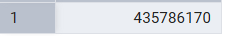

BAD LOAN PARCENTAGE
SELECT
(COUNT( CASE
WHEN loan_status='Charged Off' then id end)*100.0)
/
COUNT(ID) AS BAD_LOAN_PERCENTAGE
FROM FINANCE;
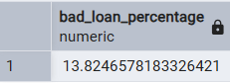

TOTAL bad APPLICATION
SELECT
COUNT(ID) AS bad_loan_application
FROM FINANCE
WHERE loan_status ='Charged Off';
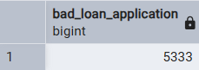

TOTAL APPLICATION FUNDED

select sum(loan_amount) as bad_loan_funded
from finance
where loan_status ='Charged Off';
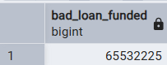

Totals bad_loan recovery
select sum(total_payment) as bad_loan_recovery
from finance
where loan_status ='Charged Off';

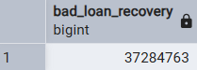

LOAN STATUS GRADE VIEW
SELECT loan_status,
COUNT(ID) AS TOTAL_APPLICATION,
SUM(total_payment) as total_amount_received,
sum(loan_amount) as total_funded_amount,
concat(round(avg(int_rate*100)::numeric,2),' %' )as interest_rate,
concat(round (avg(dti*100):: numeric,2),' %') as DTI
from finance
group by loan_status;

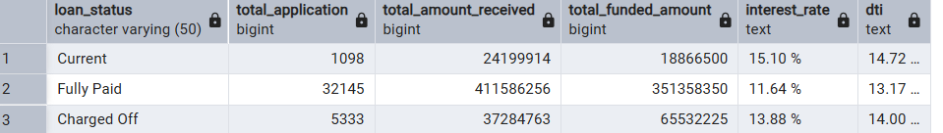

LOAN MTD STATUS GRADE VIEW

SELECT loan_status,
COUNT(ID) AS TOTAL_APPLICATION,
SUM(total_payment) as MTD_total_amount_received,
sum(loan_amount) as MTD_total_funded_amount
FROM finance
where extract (month from issue_date) =12
group by loan_status;

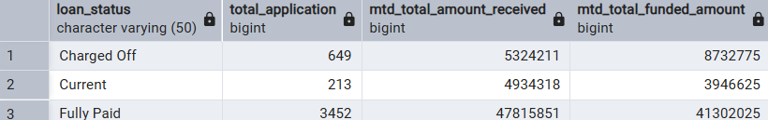

LOAN MOM STATUS GRADE VIEW
SELECT loan_status,
COUNT(ID) AS TOTAL_APPLICATION,
SUM(total_payment) as MOM_total_amount_received,
sum(loan_amount) as MOM_total_funded_amount
FROM finance
where extract (month from issue_date) =11
group by loan_status;
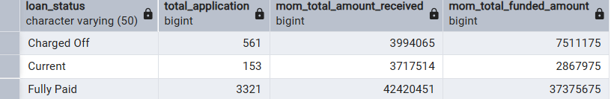

MONTHLY TRAND BY ISSUE DATE

SELECT
EXTRACT ( month from issue_date) as months,
TO_CHAR (issue_date,'MONTH') AS MONTHNAME,
COUNT(ID) AS Total_application,
SUM (total_payment) as total_Amount_Received ,
SUM (loan_amount) as total_amoun_funded
FROM FINANCE
GROUP BY months,MONTHNAME
ORDER BY months;
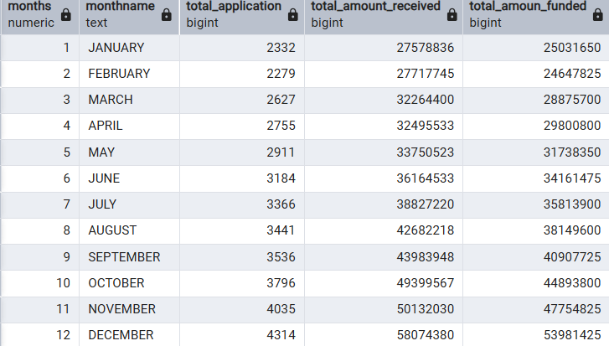

REGIONAL ANALYSIS BY STATES WISE FUNDED
SELECT
address_state,
COUNT(ID) AS Total_application,
SUM (total_payment) as total_Amount_Received ,
SUM (loan_amount) as total_amoun_funded
FROM FINANCE
GROUP BY address_state
ORDER BY total_amoun_funded DESC;
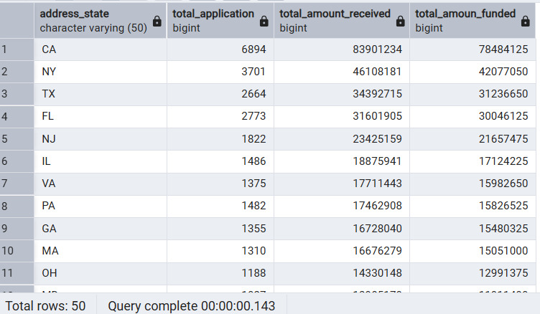
Loan term analysis
SELECT
TERM AS LOAN_TERM,
COUNT(ID) AS Total_application,
SUM (total_payment) as total_Amount_Received ,
SUM (loan_amount) as total_amoun_funded
FROM FINANCE
GROUP BY LOAN_TERM
order BY LOAN_TERM;
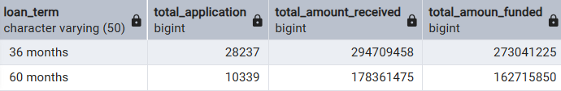

Employee length analysis
select emp_length AS emp_services,
COUNT(ID) AS Total_application,
SUM (total_payment) as total_Amount_Received ,
SUM (loan_amount) as total_amoun_funded
FROM FINANCE
GROUP BY emp_services
order BY emp_services desc;

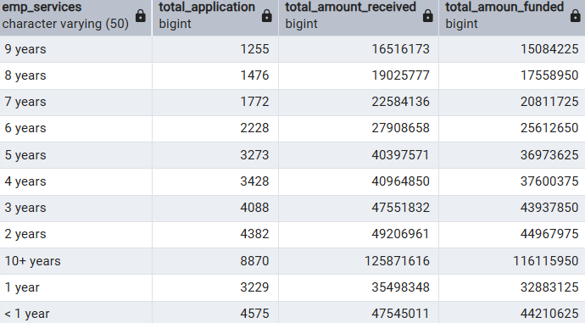

Analysis the reason behind taking loan
select purpose AS loan_reason,
COUNT(ID) AS Total_application,
SUM (total_payment) as total_Amount_Received ,
SUM (loan_amount) as total_amoun_funded
FROM FINANCE
GROUP BY loan_reason
order BY Total_application desc;
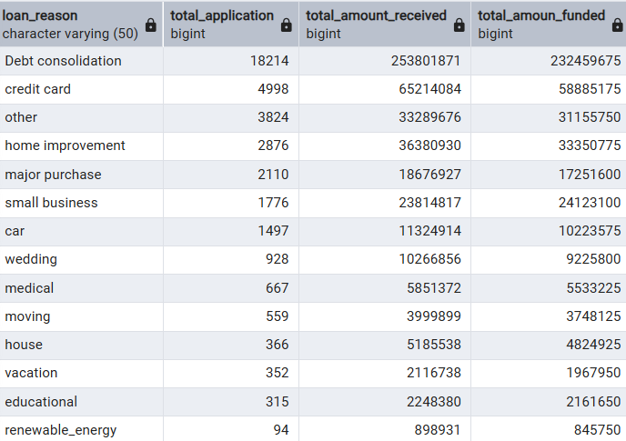

Owning properties analysis
select home_ownership ,
COUNT(ID) AS Total_application,
SUM (total_payment) as total_Amount_Received ,
SUM (loan_amount) as total_amoun_funded
FROM FINANCE
GROUP BY home_ownership
order BY Total_application desc;

